The first set of photographs are recorded by the Environmental Light Field (ELF) camera. The tripod is placed to the north of the arena and the ELF camera raised to 1.8 m above ground level, so as not to include experimenters in the images. The ELF camera base faces south, and the spirit level on the camera top (facing north) should indicate that the camera is level and pointed towards the zenith. When the “mode” button is pressed, the screen on top of the camera should read:  
“M bulb F3.5”, and indicate the camera is shooting to “raw”, has a charged battery and is saving to the SD card. The “bulb” setting allows exposure to be set via the remote trigger. The remote should have “long” underlined at the top of the display (if not, press the right arrow next to “set” until it does), which allows the exposure time to be set in hours (“00”!), minutes and seconds, using the up and down arrows and then pressing “set”. Exposure should start when the “timer start/stop” button is pressed and end automatically. If the shutter does not sound when “start” is pressed, check that “delay” is set to 00:00’00” on the remote, and that the camera’s lens is fully locked into the body.

# Imaging

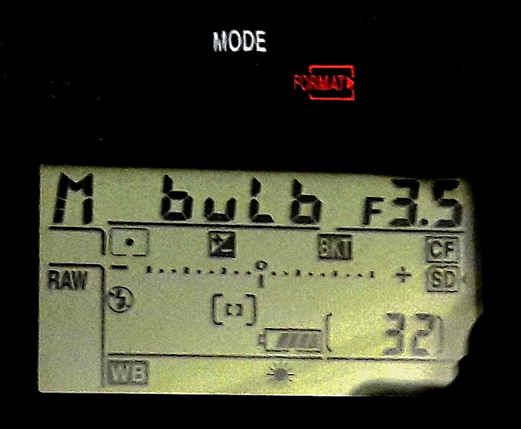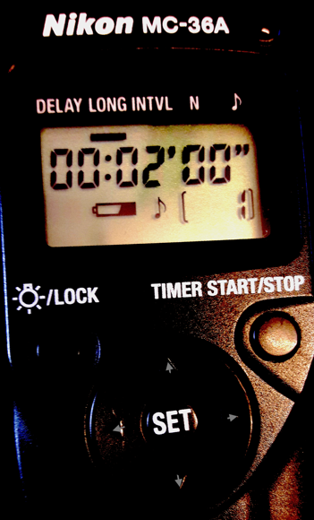

A series of 3 exposures, each repeated 3 times, should be taken before the start of the experiment. The exposure series is: 2 minutes, 30 seconds, 10 seconds. *N.B.* Each exposure is followed by an equivalent period when the camera automatically records a dark image as part of the noise reduction protocol. This means that for each 2 minute exposure, the experimenter may wait a total of 4 minutes before triggering the next exposure. When the image appears on the camera’s rear display, then next the exposure can be triggered. The whole image series should take just over 10 minutes in total.